Jhunguide Flores Dec,12,2024

BSIT 3rd Year

1. A customer places an online order, and the system divides the process into three stages: payment verification, inventory check, and shipment scheduling. However, during inventory check, the system identifies a stock shortage. What should the system do next?  
  
  
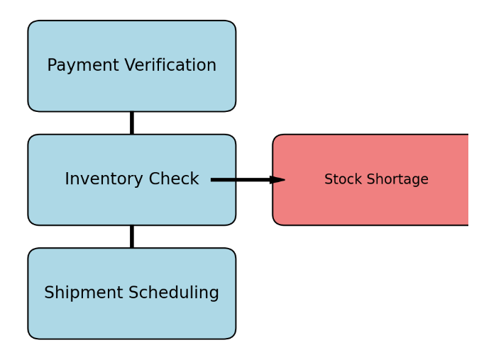

**1st Step:** The 1st Step should be informing and assuring the costumer about the stock shortage that occurs in the system and give the customer the estimate restocking date of the products.  
  
  
 **2ND Step:** It is also possible to suggest other products that have the same attributes the costumer desired. The consumer might prefer another product if they need faster delivery, rather than focusing on the exact quality.  
  
 **3rd Step:** The company may pause the order until the stock restored, they can also choose to cancel the order completely if there are problems on restocking a products. Problems that are long-term such as outbreaks or materials contamination.  
  
   
 **4th Step:** The company should update the status of the products in real time, such as product availability and product numbers to inform consumers about its exact status.  
  
  
  
2. In the image below, a customer selects items and proceeds to the checkout process. If the system fails to update inventory in real-time during this process, which of the following could occur?  
  
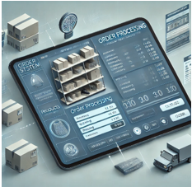  
  
  
 1St Problem: Customers may be able to purchase items that are out of stock, leading to confusion. Since the inventory doesn’t output the status in real time it can cause a false information for consumers when viewing and ordering a product.  
  
  
 2nd Problem: If the system is not updated immediately, it can cause delays for owners to identify purchase request which can lead to order delays and slow request approval.  
  
 3Rd Problem: Psychologically, delays and inaccurate stock’s status information can cause frustration to consumer leading to order dissatisfaction and disengagement.  
 4th Problem: If technical inconsistency was frequent, consumer may abandon their carts leading to loss of sales opportunities.  
  
  
  
  
  
  
 3.During peak sale periods, the system experiences delays due to high order volume. A customer places an order and receives a delayed confirmation email. How should the system handle customer expectations?  
  
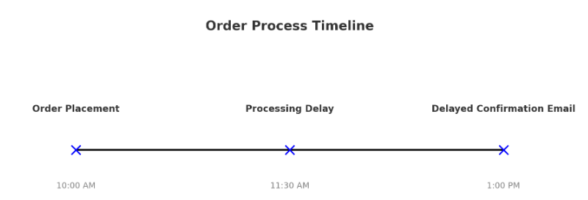  
  
  
 a. As soon as the customer places an order, the system should send an immediate acknowledgment, such as a “Thank You” page or a pop-up notification, confirming that the order has been received.   
  
 b. The system should inform customers about potential delays due to high order volume. This can be done on the checkout page or in the order confirmation message, such as: "Due to high demand, please expect a delay in receiving your confirmation email."  
  
  
 c. Seta clear estimate email confirmation for example is "You will get your confirmation email within the next 24 hours." This helps set a clear expectation and reduces customer worry.  
  
  
   
 d. If the delay is longer than expected, the system should send updates to customers. A simple message like "Your order is being processed, and you'll get a confirmation email soon" helps keep them informed.  
  
  
 e. Allow customers to check the status of their order directly on the website or app. This could include an "Order Status" page where they can see whether the order is confirmed, being processed, or shipped.  
  
  
 f. If possible, offer customers an option for priority handling or expedited service during peak periods to avoid frustration for those needing faster confirmation or processing.  
  
  
 g. If the system experiences a significant delay, a personalized apology with a discount or offer for the next purchase can help mitigate negative sentiment and enhance customer loyalty.

nt.